Computer Design and Application
Project Report [IA-II]
Topic:- LED pattern generator using 8086 and 8255 PPI.
Software Used: Proteus 8 Professional
1. Purpose of the Project - This project shows how the 8086 microprocessor controls 16 LEDs patterns using the 8255 PPI based on the program.
2. Components in the Circuit - Intel 8086 Microprocessor ,74LS373 latch (to separate address/data lines), 8255 Programmable Peripheral Interface ,16 LEDs (8 on Port A, 8 on Port B) ,Clock, reset, and power supply.
3.Working- The 8086 sends data to the 8255 through latched address lines, which select Port A and Port B. The 8255 outputs this data to 16 LEDs, generating different blinking and shifting patterns.
4.How to use the Project file- Open the Proteus (LED Generator.pdsprj) file → Double-click the 8086 in the circuit → Load the binary or executable file (Led Blinking program.bin) → Click Run in Proteus or Go to debug ( in the top) → Click Run Simulation.(Left-side LEDs show Port-A patterns, and right-side LEDs show Port-B patterns). With the help of pictures below we can access the proteus project .
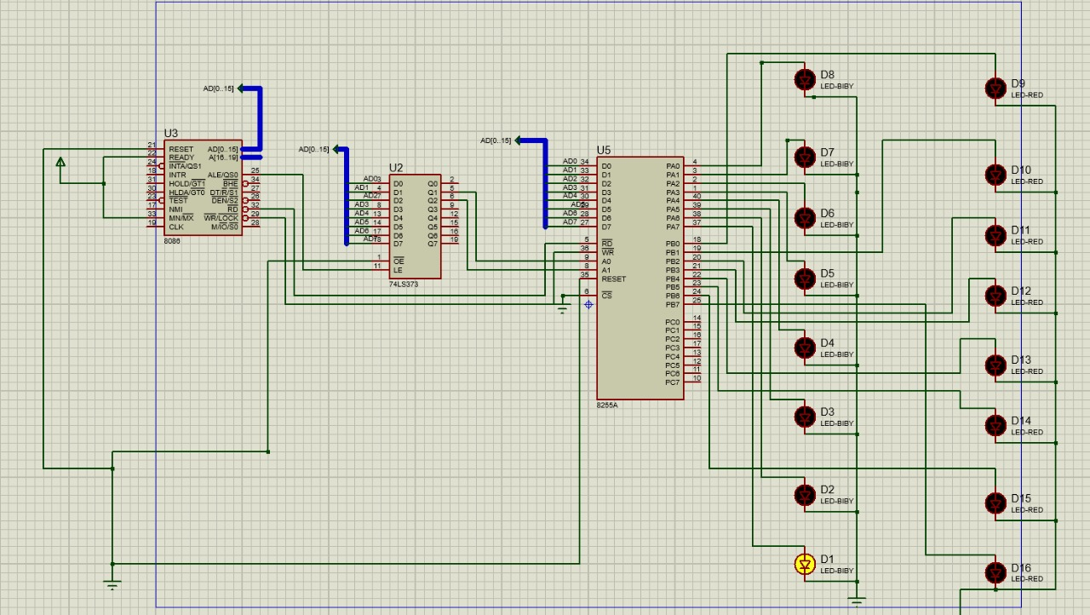 → 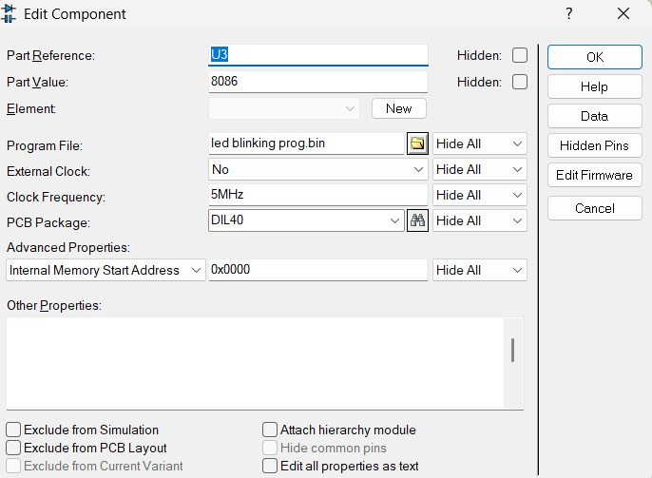 →
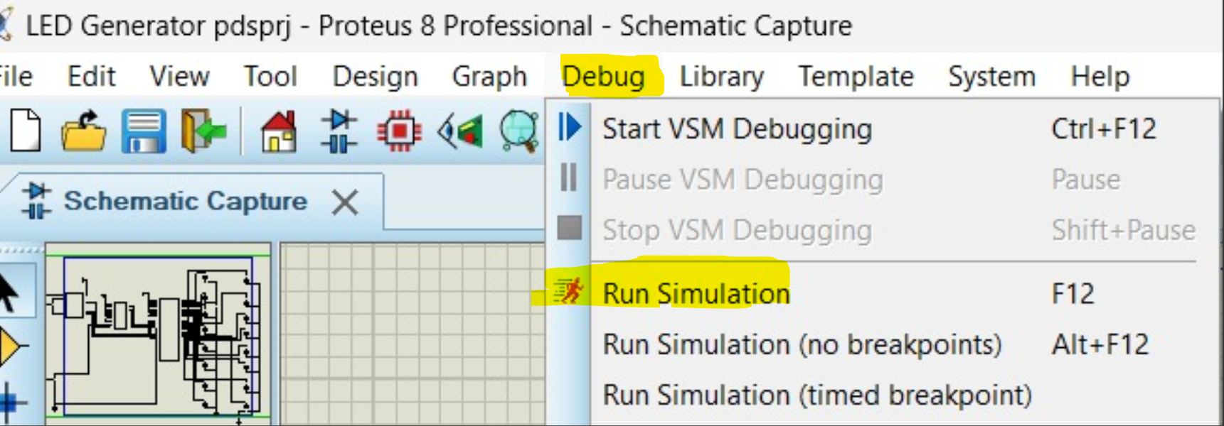 → 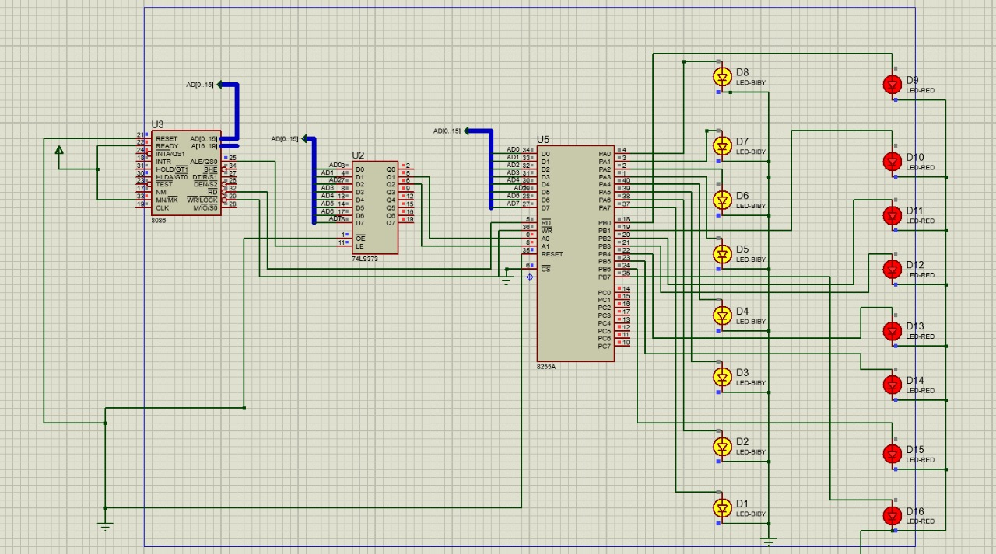
Submitted by Group Members :-


